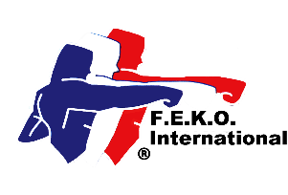

Federation of English Karate Organisations International

In direct membership to

the World Union of Karate-Do Federations

# Federation of English Karate Organisations

**Federation of Martial Arts**

in direct membership to the World Kobukan Federation

www.feko.co.uk E-mail: jimreece@kaizenmartialarts.co.uk

Jim Reece, Hon-Secretary, 234 West Park Drive West, Roundhay, Leeds LS8 2BD. Tel 07940 565046

**FMA Annual Association Membership 2025**

**Complete all parts**

|  |
| --- |
| Association  Contact name  Position  Address  Post code Tel No Mobile No  E-mail Web site  Do you want your website linked to the FEKO website? Yes  No  Chief Instructor’s name  Address  Post code Tel No Mobile No  E-mail Grade |

I enclose a cheque for £50.00 for continued Federation membership

I have transferred £50.00 by BACS directly into the FEKO International Account

I enclose a *cheque for £ 100.00/*. I have transferred by BACs the sum of £100.00 for lapsed membership and the reinstatement of my Association and individual members’ insurance coverage. (Maximum time limit 3 months). (*delete as necessary). Without the membership renewal payment, all insurance coverage ceases on 31 January 2025 and is only reactivated from receiving the late payment.

Instructors must have Instructor Indemnity Insurance, be registered under the Federation’s Safeguarding Child & Vulnerable Adult Protection Policy, and have an enhanced DBS clearance and first aid certificates.

Signed Date

Print name: Position

Please make all cheques payable to FEKO International. A registration certificate will be issued. Send to Jim Reece at the above address.

|  |
| --- |
| Official use only. Date received. Fee enclosed £ Date certificate issued. |