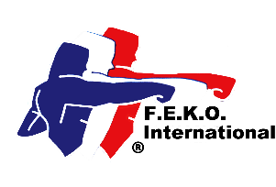

Federation of English Karate Organisations International

In direct membership to

the World Union of Karate-Do Federations

# Federation of English Karate Organisations

**Federation of Martial Arts**

in direct membership to the World Kobukan Federation

www.feko.co.uk E-mail: jimreece@kaizenmartialarts.co.uk

Jim Reece, Hon-Secretary, 234 West Park Drive West, Roundhay, Leeds LS8 2BD. Tel 07940 565046

**Annual Association Membership 2025**

**Complete all parts.**

|  |
| --- |
| Association  Contact name  Position  Address  Post code Tel No Mobile No  E-mail Web site  Do you want your website linked to the FEKO website? Yes  No  Chief Instructor’s name  Address  Post code Tel No Mobile No  E-mail Grade |

I enclose a cheque for £100.00 for continued Federation membership

I have transferred £100.00 by BACS directly into the FEKO International Account

I enclose a *cheque for £ 150.00/*. I have transferred by BACs the sum of £150.00 for lapsed membership and the reinstatement of my Association and individual members’ insurance coverage. (Maximum time limit 3 months). (*delete as necessary). Without the membership renewal payment, all insurance coverage ceases on 31 January 2025 and is only reactivated from receiving the late payment.

Insurance requirements: All Instructors must have Instructor Indemnity Insurance, be registered under the Federation’s Safeguarding Child & Vulnerable Adult Protection Policy, have an enhanced DBS clearance certificate and a first aid certificate.

Signed Date

Print name: Position

|  |
| --- |
| Please make all cheques payable to FEKO International. A registration certificate will be issued. Send to Jim Reece at the above address. Official use only. Date received. Fee enclosed £ Date certificate issued. |